Grade 8 Math
(%)…BEDMAS…Formula…Exponents…Compound Interest
We are combining numerous skills---Whoa!!
Let’s make some money

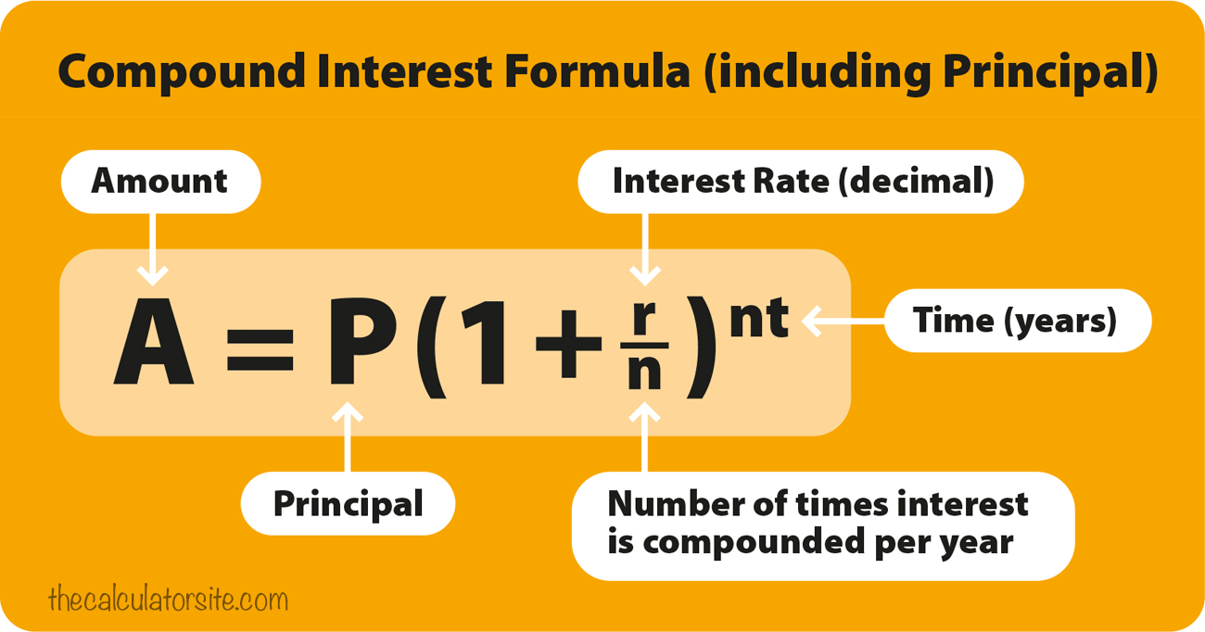

Let's look at an example
Compound interest formula (including principal):
A = P(1+r/n)^{(nt)}
If an amount of $5,000 is deposited into a savings account at an annual interest rate of 5%, compounded monthly, the value of the investment after 10 years can be calculated as follows...

P = 5000. r = 5/100 = 0.05 (decimal). n = 12. t = 10.
If we plug those figures into the formula, we get:
A = 5000 (1 + 0.05 / 12) ^ (12(10)) = 8235.05.
So, the investment balance after 10 years is $8,235.05.

Looks like free money was made. How much was made __________________?
Looks like a good investment.
This formula has numerous variables
Let’s see how much money we will make if we change the interest rate (change the % rate)

List all the variables in this formula | List the variable(s) that we will control | List the variable(s) we will manipulate | List the responding variable(s)

Calculate the amount of money made using different interest rates

Interest rate  r  % | Write the formula with all the necessary numbers  Do calculations on a separate sheet and staple to this sheet | Amount  A
4

6

8

10

